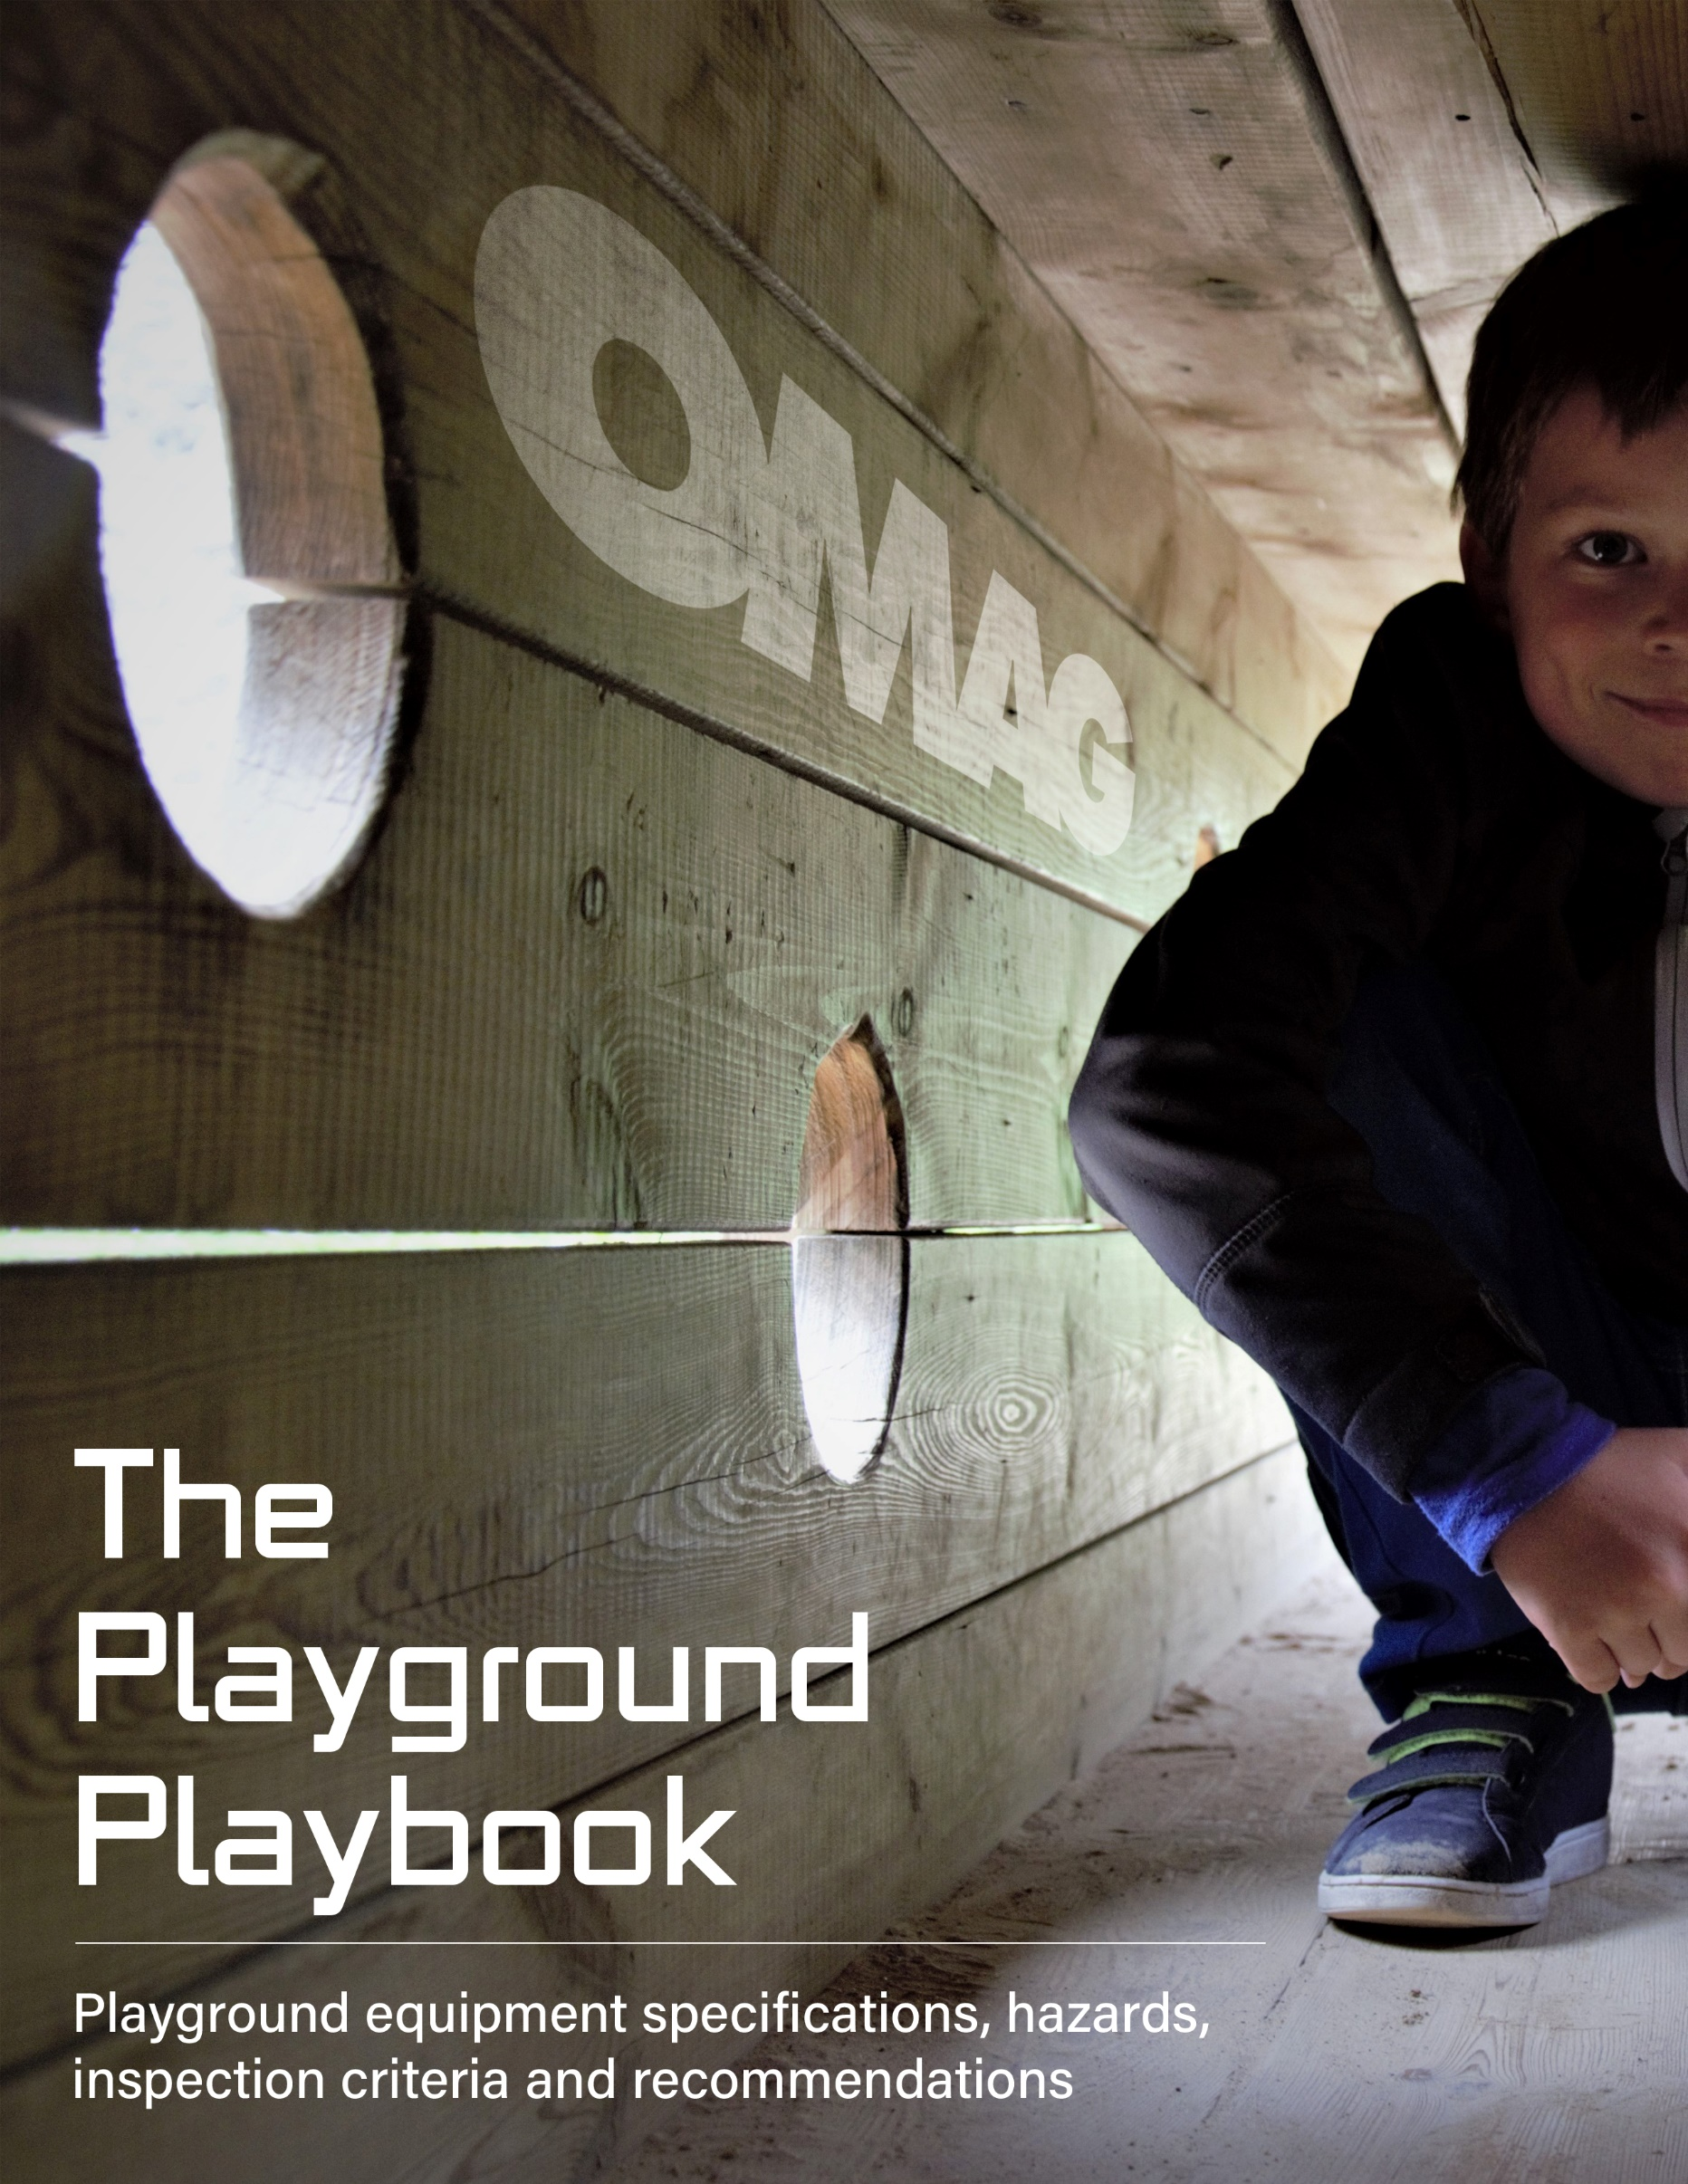

TABLE OF CONTENTS

TOPIC PAGE(S)

PLAYGROUND INJURY STATISTICS 1-2

PLAYGROUND DEFINITIONS 2-4

EQUIPMENT SPACING AND USE ZONES 5-6

PLAYGROUND INSPECTIONS 6

EQUIPMENT SPECIFICATIONS 7-9

EQUIPMENT RECOMMENDATIONS

Rung Ladders, Arch Climbers 10
Balance Beams 10
Sliding Pole 10-11
Upper Body Equipment 11
Log Rolls 11
Merry-Go-Rounds 12
Track Ride 12
Spring Rockers 12
Seesaws (Teeter Totter) 13
Stepping Forms 13
Slides 13-15
To-Fro Swings 15-17
Tire Swings 17-18

The Dirty Dozen 19-26
(Including a Playground Inspection Safety Checklist)
America's playgrounds are not as safe as we'd like to think. Recently, the National Program for Playground Safety graded each state on the safety of its playgrounds, awarding an averaged national grade of C+. Additionally, a Consumer Product Safety Commission (CPSC) study found that more than 200,000 children suffered playground injuries serious enough to be seen in an emergency room.

Among the CPSC findings:

- More than three-quarters of injuries (76 percent) occurred on public playground equipment, while 23 percent occurred on home equipment.
- Of the injuries on public playground equipment, 45 percent occurred on school playgrounds, and 31 percent occurred in public parks.
- Fifteen percent of injuries were classified as severe.
- The most common type of injury was fractures (39 percent), most involving the wrist, elbow and lower arm. Lacerations accounted for 22 percent of injuries, contusions or abrasions 20 percent, and strains or sprains 11 percent.
- Falls to the playground surface were involved in 79 percent of all injuries.
- Girls were slightly more likely to be injured (55 percent of injuries) than were boys (45 percent).
- In children aged 4 and under, the most common injuries (49 percent) were to the head and face. Most of these injuries occurred on climbing equipment and slides.
- In children ages 5 to 15, the most common injuries (49 percent) were to the arm and hand, and most occurred on climbing equipment and swings.

The CPSC also looked at deaths resulting from playground equipment. More than half (56 percent) involved hanging, primarily from ropes, shoestrings, cords, leashes, clothing strings, and other items either tied to or entangled with the equipment.

Even though the ASTM 1487 (American Society for Testing and Materials) – Specifications for Playground Equipment for Public Use – is a voluntary standard, it is easy to see why compliance should be strictly adhered to.

PLAYGROUND DEFINITIONS

Completely Bounded Opening

Any opening in a piece of playground equipment that is totally enclosed by boundaries on all sides so that the perimeter of the opening is continuous. Tested to determine if the opening is an Entrapment Hazard. See Entrapment Hazards for test procedures.

Designated Play Surface

A designated play surface is any elevated surface that could be used for standing, walking, crawling, sitting, or climbing, or a flat surface greater than 2 inches wide by 2 inches long having an angle less than 30 degrees from horizontal.

Entrapment Hazard

Any condition which impedes withdrawal of a body or body part that has penetrated an opening.

Certain openings could present an entrapment hazard if the distance between any interior opposing surfaces is great than 3.5 inches and less than 9 inches. If the smaller test probe (represents a small child’s torso) does not pass through the opening, the opening is compliant, and no entrapment hazard exists. If the smaller test probe passes through the opening - the larger test probe (represents a large child’s head) must also pass through the opening. If the larger test probe cannot pass through, the opening is non-compliant, and presents an entrapment hazard.

Entanglement Hazard

Any condition in which the user’s clothes or something around the user’s neck becomes caught in or entwined on a component of playground equipment.

Fall Height

Vertical distance between a designated play surface and the protective surfacing beneath it.

Maximum User

12 year old child: measurement characteristics are the 95th percentile values.

Minimum User

2 year old child: measurement characteristics are the 5th percentile values.

Partially Bounded Openings

Any opening in a piece of playground equipment that is not totally enclosed by boundaries on all sides so that the perimeter of the opening is discontinuous.

Projection

Condition which, due to its physical nature, must be tested to the requirements of the standard to determine whether it is a protrusion or entanglement hazard or both.

Protrusion

Projection which, when tested in accordance with the requirements of the standard, is found to be a hazard having the potential to cause bodily injury to a user who impacts it.

Determining if a Projection is a Protrusion

Successively place each of three gauges over each accessible projection in all orientations. Determine whether the projection extends beyond the face of any gauge. The projection fails the test and is a protrusion if it extends beyond the face of any of the three gauges.

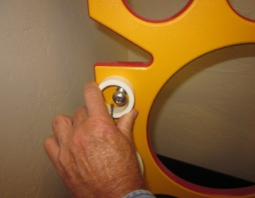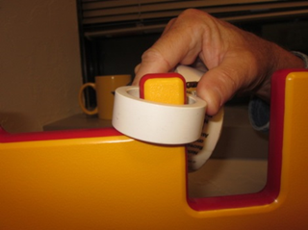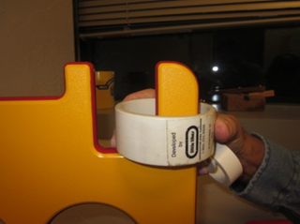
Inside Diameter
.50 inches 1.50 inches 3.00 inches

Outside Diameter
1.00 inches 2.00 inches 3.50 inches

Thickness
0.25 inches 0.75 inches 1.50 inches
PLAYGROUND EQUIPMENT SPACING & USE ZONES

There should be a use zone for each play structure which shall consist of obstacle-free surfacing that is appropriate for the fall height of the equipment. The use zone for stationary play equipment shall be no less than 72 inches (6 feet) from all sides of the play structure.

Equipment that is intended for the user to maintain contact with the ground during play has no individual use zone requirements (free standing talk tubes, free standing activity panels, ground level sandboxes, etc.)

The use zone of stationary equipment and other equipment may overlap depending on the type of equipment involved. The use zone for playground equipment that has motion, such as swings, merry-go-rounds, and slides shall not overlap with any other equipment.

Even in cases where the use zones may overlap, the distance between play equipment has to meet the following recommendations.

If the adjacent play surfaces of each structure are no more than 30 inches above the protective surface, the minimum distance between the Equipment shall be 6 feet. If the adjacent designated play surfaces of either piece of equipment are greater than 30 inches above the play surface, the minimum distance shall be 9 feet.

The use zone for the end of the slide chute should extend a minimum 6 feet to a maximum of 8 feet.

The use zones to the front and rear of to-fro swings should be twice the distance from the pivot of the swing to the top of the protective surface. For toddler swings it is twice the distance from the pivot point to the bottom of the seat.
Overhead obstructions within the use zones of playground equipment that are not part of the play structure (for example, tree limbs) shall not be within 84 inches of each designated play surface, the use zone, or above the pivot point of swings.

Protective Surfacing in the Use Zones

The depth of the material depends on the type of material being used and the fall height of the equipment.

Inches of Loose fill material Protects to Critical (fall) Ht.
9 Shredded/recycled rubber 10
9 Sand 4
9 Pea Gravel 5
9 Wood Mulch (non CCA) 7
9 Wood Chips 10

PLAYGROUND INSPECTIONS

Inspections can be high frequency, for busy playgrounds, or low frequency, for those that see comparatively little use. Inspections should be tailored to the manufacturers’ recommendations and to your needs. All inspections should be documented with at least the date the hazard was discovered and the date it was corrected. Any other paperwork associated with playground equipment, i.e. manufacturers’ instructions, work orders and purchase orders should also be retained in a permanent file. It is recommended that any replacement parts (s-hooks, swing chains, slide chutes, etc.) be purchased from the manufacturer or another playground equipment source.

EQUIPMENT SPECIFICATIONS

Burn Warning

All materials that make up the play ground, (equipment, surfacing materials, etc.) have the potential to cause serious burns to users. Younger children are more at risk because they don’t react by pulling away, this lack of action results in a more serious burn.

Unshaded equipment can have a surface temperature of 40 to 60 degrees higher than the outside air temperature. Materials can reach 140 degrees even on a cloudy day with a high temperature of 80 degrees.

A serious burn can occur within a matter of minutes on anything over 120 degrees, if the surface temperature is above 140 degrees it will only take a few seconds of exposure to burn the skin.

To assist in preventing burns the equipment can be shaded by trees, tarps, canopies, etc.

Hand Rails

Hand rail that are used for ascending and descending shall be between 0.95 and 1.55 inches in diameter.

Ropes, Cables, and Chains

Rope, cable, or chain with a length of 7.0 inches or less may be attached at one end only.
Rope, cable, or chain shall be fixed at both ends and not be capable of being looped back on itself, creating an inside loop perimeter greater than 5.0 inches or a diameter of 1.6 inches.
Swing chains are exempt.

S-Hooks

An S-hook is considered closed if there is no gap or space greater than 0.04 inches (about the thickness of a dime). The bottom loop of the S- hook cannot extend past or overlap the body of the S-hook. The top loop may overlap the body, but may not extend past it.

Exposed Bolt End Projections

Any accessible bolt end projecting beyond the face of the nut more than two full threads is an entanglement hazard.

Open Ends of Pipes and Tubes

Exposed open ends of all pipes, tubes, etc., shall be provided with caps or plugs that cannot be removed without the use of tools.

Projections Which Increase in Size

Any projection which increases in size or diameter from the initial surface to the outer end is an entanglement hazard.

Guardrails and Barriers

Guardrails or barriers are required on elevated surfaces that are greater than:
- 20 inches above the protective materials for equipment designed for 2 – 5 year olds.
- 30 inches above the protective materials for equipment designed for 5 – 12 year olds.

Guardrails or barriers should be provided on platforms, landings, walkways and ramps. Guardrails should completely surround the elevated surface except for entry and exit openings. Barriers should be designed to discourage climbing and protect against children climbing through the barrier.

Guardrail Barrier

A
A

B
B

H
H

 | Guardrail | Barrier
Protects against falls  Discourages climbing over  Protects against climb thru | Yes  No  No | Yes  Yes  Yes
Toddlers  A – Top Edge to platform  B – Bottom edge to platform  H- Platform fall height | Not Recommended | A = 24” or higher  B < 3”  H = 18” or higher
2-5 year olds  A – Top Edge to platform  B – Bottom edge to platform  H- Platform fall height | A = 29” or higher  9” < B < 23”  20” < H < 30” | A = 29” or higher  B < 3.5”  H > 30”
5-12 year olds  A – Top Edge to platform  B – Bottom edge to platform  H- Platform fall height | A = 38” or higher  9” < B < 28”  30” < H < 48” | A = 38” or higher  B < 3.5”  H > 48”

EQUIPMENT RECOMMENDATIONS

Equipment NOT RECOMMENDED for use on public playgrounds
- Trampolines
- Swinging Gates
- Giant Strides
- Climbing Ropes not secured at both ends
- Heavy Metal Swings
  - Animal swings
  - Wooden or heavy metal seats
- Swinging dual rings and trapeze bars

Rung Ladders, Flexible Components, and Arch Climbers Recommendations

The final stepping surface used for final access shall not be above the designated play surface it serves.

Balance Beams Recommendations

The top surface of the balance beams shall be no greater than:

- 12 inches above the protective surface for 2-5 year olds, and
- 16 inches above the protective surface for 5-12 year olds.

Sliding Poles Recommendations

- Clearance distance from structure to pole shall be between 18 and 20 inches. Pole diameter shall not be more than 1.9 inches.
- Sliding pole shall rise 60 inches or greater above the surface of the platform.
- The guardrail/barrier at a platform entrance/exit shall have an opening with a maximum horizontal distance of 15 inches.

Upper Body Equipment Recommendations

- Center to center distance between rungs with fixed handholds shall be no greater than 15 inches. Handgrips shall be between 0.95” to 1.55” diameter.
- Horizontal distance from the leading edge of the take-off or landing structure, out to the first hand hold shall be no greater than 10 inches.
- Where take-off and landing is provided by means of rungs, the distance to the first handhold shall be no less than 8 inches, but no greater than 10 inches.
- Maximum height:
  - 60 inches for 2 – 5 year olds.
  - 84 inches for 5-12 year olds.
- Take-off and landing structures maximum height:
  - 18 inches for 2-5 year olds.
  - 36 inches for 5-12 year olds.
- Ladder Rung spacing should be greater than 9”, but less than or equal to 12”, measured from top of rung to top of rung.
- For moveable handing rings and hanging rings, the distance from the pivot to the bottom of the handhold shall not exceed 15 inches. Any flexible element (cable, chain) used to support the handhold shall not exceed 7 inches.

Log Roll Recommendations

- Highest point at the top of the roller shall not be greater than 18 inches above the protective surface.
- Handgrips will be provided to aid in mounting and dismounting.
Merry-Go-Round Recommendations

- The standing/sitting surface shall have a maximum height of:
  - 14 inches above the protective surface for 2 – 5 year olds.
  - 18 inches above the protective surface for 5 – 12 year olds.
- The underside of the platform at the outermost perimeter shall be no less than 9 inches above the level of the protective surface.
- The use zone extends 6 feet in all directions and should not be shared with any other play structure.

Track Ride Recommendations

- The lowest portion of the hand gripping component shall be:
  - A minimum of 64 inches above the protective surface and
  - A maximum of 78 inches above the protective surface.
- When elevated platforms are used they shall have a landing space with a minimum length of 36 inches and a minimum width of 32 inches.
- Center to center distance between adjacent tracks shall be at least 48 inches.

Spring Rockers Recommendations

- Seat height not less the 14 inches and not more than 28 inches above the protective surface.
- Handgrips will be provided. Minimum 3 inches for one hand, 6 inches for both.
- Footrests shall be provided that have a minimum width of 3.5 inches.
- Spring equipment intended for standing has an 84 inch use zone.

Seesaws (Teeter Totter) Recommendations

- Seesaws without a spring centering mechanism should have shock-absorbing material, such as an automobile tire, embedded in the underlying protective surface beneath the ends of the seesaw, or secured to the underside of each occupant seat.
- Maximum attainable seat height is 60 inches.
- Handgrips will be provided. Minimum 3 inches for one hand, 6 inches for both.
- Footrests are only allowed on seesaws equipped with a spring centering mechanism.

Stepping Forms Recommendations

- The form shall have a minimum diameter of 10 inches.
- Maximum height (without hand supports):
  - 20 inches above the protective surface for 2 – 5 year olds.
  - 30 inches above the protective surface for 5 – 12 year olds.
- Hand supports shall be provided at the beginning of a stepping form that is higher than the maximum height listed above.
- The hand support height shall be between 22 and 38 inches from the top of the stepping form.
- Maximum distance between stepping forms:
  - 12 inches when designed for 2 – 5 year olds.
  - 18 inches when designed for 5 – 12 year olds.

Slide Recommendations

- The slide chute inside width shall be:
  - 12 inches or greater when designed for 2 – 5 year olds.
  - 16 inches or greater when designed for 5 – 12 year olds.
- Flat, open chutes shall have sidewalls with a height of 4 inches or greater that extend along both sides of the chute for the entire length of the sliding surface.
- Internal diameter of tube slides shall be 23 inches or greater.
- The exit region of the slide chute shall be at least 11 inches.

Exit Region

- For slides with an elevation of less than 48 inches, the height of the exit end of the sliding surface shall be no greater than 11 inches above the protective surface.
- For slides with an elevation greater than 48 inches, the height of the exit end of the sliding surface shall be between 7 and 15 inches above the protective surface.
- The use zone for the end of the slide chute should extend a minimum 6 feet to a maximum of 8 feet.

All slides should be provided with a transition platform with sufficient length to facilitate the transition from standing to sitting at the top of the inclined sliding surface.

The transition platform should:
- Be at least 14 inches deep for preschool and school age children.
- Be at least as wide as the slide chute.
- Be surrounded by guardrails or barriers.
- Not have any spaces or gaps that could trap strings, clothing, body parts, etc. between the platform and the start of the slide chute.
- Provide handholds to facilitate the transition from standing to sitting.
- Provide a means to channel a user into a sitting position at the entrance to the chute, such as a guardrail, hood, or other device.
- Have no entanglement hazards on the slide chute.

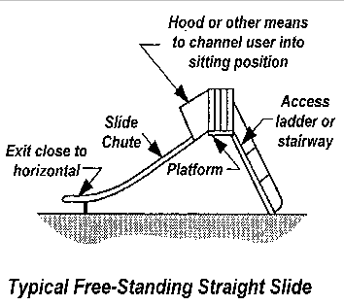

General Swing (To-Fro Swings) Recommendations

- Swings should be located away from other play structures and circulation routes.
- Support structure should be designed to discourage climbing.
- A-Frame support structures should not have horizontal crossbars.
- No more than two swings within one bay. There is not a limit to the number of bays.
- No heavy wooden or metal seats.
- The use zones to the front and rear of to-fro swings should be twice the distance from the pivot of the swing to the top of the protective surface. For toddler swings it is twice the distance measured from the bottom of the seat to the pivot point.
- The use zones on the sides shall be six feet.
- H is equal to the distance from the pivot to the top of the protective surfacing. For toddler full bucket seats – H is from the pivot to the bottom of the seat. Maximum top beam height is 96 inches for toddler swings.

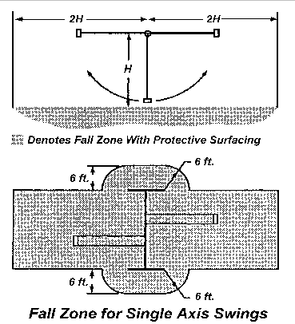

Clearances for Swings

- Horizontal distance between the supporting structure and the adjacent swing (D1) shall be no less than 30 inches, measured at 60” from surface. For full bucket toddler swings (D1) shall be no less than 20 inches.
- Horizontal distance between adjacent swings (D2) shall be no less than 24 inches. For full bucket toddler swings (D2) shall be no less than 20 inches.
- Horizontal distance between the points where to-fro swings attach to the hangers (D3) shall be greater than the width of the seat, but not less than 20 inches. Same for full bucket toddler seats.
- The vertical distance between the underside of the seat and the top of the protective surface (D4) shall be no less than 12 inches. Full bucket toddler seats shall be no less than 24 inches above protective surface.
- The fall height is the distance between the pivot point and the top of the protective surface.

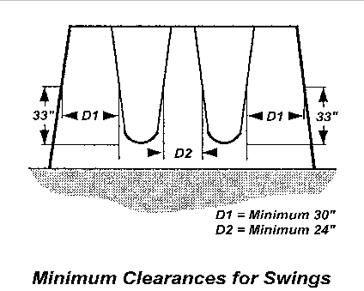

D4

D3
Location | Descriptions | Toddler Seats | Belt Seats
D1 | Support to Chain | 20” | 30”
D2 | Distance to Adjacent Swing | 20” | 24”
D3 | Distance from Pivot to Pivot | 20” | 20”
D4 | Distance from Seat to Surface | 24” | 12”

Tire (Rotating Multiple-Axis Swing) Swing Recommendations

- Swings should be located away from other play structures and circulation routes.
- Support structure should be designed to discourage climbing.
- No more than one swing within one bay. There is not a limit to the number of bays.
- No heavy wooden or metal seats. Suspended member shall not be over 35 pounds.

Clearance for Tire (Rotating Multiple-Axis Swing) Swings

- The clearance zone is a cylindrical unobstructed zone centered on the pivot point of the swing with a radius equal to L + 30 inches. L is equal to the distance from the pivot point of the swing to the top of the sitting surface.
- The vertical distance between the underside of the seat, when occupied by the design capacity of maximum users, and the protective surface of the use zone shall be not less than 12 inches.
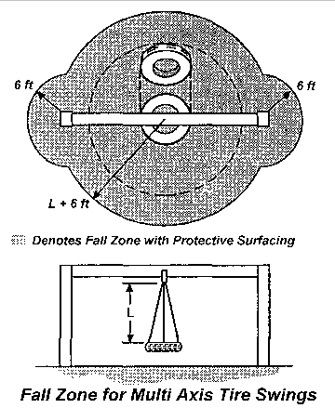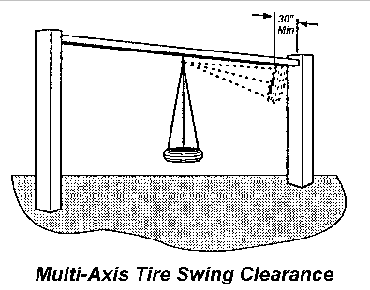

The Dirty Dozen...

Are they hiding in your municipality’s playground?

In the time it will take you to read the remainder of this booklet, a child will be severely injured and admitted to an emergency room as a result of a playground-related accident. Consumer Product Safety Commission (CPSC) statistics show that every year over 200,000 such injuries occur. Approximately twenty children will die from playground related injuries. A playground should allow children to develop progressively and test their skills by providing a series of graduated challenges. The challenges presented should be appropriate for age-related abilities and should be ones that children perceive and choose to undertake. The National Playground Safety Institute (NSPI) has identified twelve of the leading causes of injury on playgrounds. By familiarizing yourself with the “Dirty Dozen Checklist” you can inspect your municipality’s playgrounds to see how safe they are. Municipal decision-makers are responsible for providing safe play opportunities for the citizenry.

The Dirty Dozen Checklist...

1. Improper Protective Surfacing
2. Inadequate Fall Zone
3. Protrusion & Entanglement Hazards
4. Entrapment in Openings
5. Insufficient Equipment Spacing
6. Trip Hazards
7. Lack of Supervision
8. Age-Inappropriate Activities
9. Lack of Maintenance
10. Sharp Points, Corners and Edges
11. Platforms with No Guard Rails
12. Equipment Not Recommended for Public Playgrounds
1. Improper Protective Surfacing

Because falls account for so many injuries, protective surfacing is the single most important safety consideration in any playground. Generally, there are two classifications of shock absorbing materials, unitary and loose fill.

Unitary Materials
Unitary surfaces include rubber, rubber over foam mats or various rubber and urethane materials poured into place.

Advantages:
• Low maintenance
• Easy to clean
• Consistent shock absorbency
• Generally low life cycle costs
• Accessible to the handicapped

Disadvantages:
• Initial cost relatively high
• Additional under-surfacing is critical for thinner materials
• Subject to vandalism
• Full rubber tiles may curl up and cause tripping

Loose-Fill Materials
Loose-fill surfaces include shredded wood products, sand and gravel.

Advantages:
• Low initial cost
• Ease of installation
• Materials readily available
• Not susceptible to vandalism

Disadvantages:
• Over time, cushioning potential is reduced by use and environment
• May be blown or thrown into children’s eyes
• Conceals foreign objects

2. Inadequate Fall Zone

A fall zone is the area under and around the playground equipment where a child might fall. Fall zones should be covered with protective surfacing material and extend a minimum of six feet in all directions from the edge of stationary play equipment such as climbers or chin up bars. The fall zone at the bottom or exit area of a slide should extend a minimum of six feet from the end of the slide for slides four feet or less in height. For slides higher than four feet, take the entrance height of the slide and add four feet to determine how far the surfacing should extend from the end of the slide. Swings require a larger area for the fall zone. The fall zone should extend two times the height of the pivot or swing hanger in front of and behind the swing seats. The fall zone should also extend six feet to the side of the support structure.

3. Protrusion & Entanglement Hazards

A protrusion hazard is a component or piece of hardware that might be capable of impaling or cutting a child if a child should fall against the hazard. Some protrusions are also capable of catching strings or items of clothing that might be worn around a child’s neck. This type of entanglement is especially hazardous because it might result in strangulation. Examples of protrusion and entanglement hazards include bolt ends that extend more than two threads beyond the face of the nut, hardware configurations that form a hook or leave a gap between components and open “S” type hooks. Rungs or handholds that protrude outward from a support structure may be capable of penetrating the eye socket. Special attention should be paid to the area at the top of slides and sliding devices. Ropes should be anchored securely at both ends and not be capable of forming a loop or noose.

4. Entrapment in Openings

Enclosed openings on playground equipment must be checked for head entrapment hazards. Children often enter openings feet first and attempt to slide through the opening. If the opening is not large enough it may allow the body to pass through the opening and entrap the head.
Head entrapment by head-first entry generally occurs when children place their heads through an opening in one orientation, turn their heads to a different orientation, then are unable to withdraw from the opening. There should be no openings on playground equipment that measure between three and one half inches and nine inches. Where the ground forms the lower boundary of the opening is not considered to be hazardous. Pay special attention to openings at the top of a slide, openings between platforms and openings on climbers where the distance between rungs might be less than nine inches.

5. Insufficient Equipment Spacing

The playground should be organized into different areas to prevent injuries caused by conflicting activities and children running between activities. Active, physical activities should be separate from more passive or quiet activities. Areas for play equipment, open fields and sand boxes should be located in different sections of the playground. In addition, popular, heavy-use pieces of equipment or activities should be dispersed to avoid crowding in any one area. The layout of equipment and activity areas should be without visual barriers so that there are clear sight lines everywhere on the playground to facilitate supervision.

Moving equipment, such as swings and merry-go-rounds, should be located toward a corner, side or edge of the play area while ensuring that the use zones around the equipment are maintained. Slide exits should be located in an uncongested area of the playground. Use zones for moving equipment, such as swings and merry-go-rounds, and at slide exits should not overlap the use zones of other equipment, regardless of height.

6. Trip Hazards

All anchoring devices for playground equipment, such as concrete footings, should be installed well below ground level, beneath the base of the protective surfacing material, to eliminate the hazard of tripping. This will also prevent children who may fall from sustaining additional injuries due to exposed footings. Low retaining walls are commonly used to help contain loose surfacing materials. In order to minimize trip hazards, retaining walls should be highly visible and any change of elevation should be obvious. The use of bright colors can contribute to better visibility.

7. Lack of Supervision

Playgrounds that are designed, installed and maintained in accordance with safety guidelines and standards can still present hazards to children in the absence of adequate supervision. It is estimated that over 40% of all playground injuries are directly related to lack of supervision in some way. The supervision of a playground environment directly relates to the overall safety of the environment. A play area should be designed so that it is easy for a parent or caregiver to observe children at play. Young children are constantly challenging their own abilities, very often not being able to recognize potential hazards. Playground supervisors should be aware that not all playground equipment is appropriate for all children who may use the playground. Supervisors should look for posted signs indicating the appropriate age of the users and direct children to equipment appropriate for their age. It is important to recognize that pre-school age children require more attentive supervision on playgrounds than older children.

8. Age-Inappropriate Activities

In playgrounds intended to serve children of all ages the layout of pathways and the landscaping of the playground should show the distinct areas for the different age groups. The areas should be separated at least by a buffer zone, which could be an area with shrubs or benches. Signs posted in the playground area can be used to give some guidance to adults as to the age appropriateness of the equipment.

9. Lack of Maintenance

Inadequate maintenance of equipment can result in injuries on playgrounds. Because the safety of playground equipment and its suitability for use depend on good inspection and maintenance, the manufacturer’s maintenance instructions and recommended inspection schedules should be strictly followed. A comprehensive maintenance program should be developed for each playground. All equipment should be inspected frequently for any potential hazards and for corrosion or deterioration from rot, insects or weathering. The playground area should also be checked frequently for broken glass or other dangerous debris. Loose-fill surfacing materials should be inspected to ensure they have not become displaced or compacted in high traffic areas such as under swings and at slide exits. Any damage or hazards detected during inspections should be repaired immediately in accordance with the manufacturer’s instructions for repair and replacement of parts. For each piece of equipment, the frequency of thorough inspections will depend on the type of equipment, the amount of use and the local climate. Based on the manufacturer’s recommendations regarding maintenance schedules for each piece of equipment, a maintenance schedule for the entire playground can be created. Detailed inspections should give special attention to moving parts and other components which can be expected to wear. Inspections should be carried out in a systematic manner by trained personnel. One possible procedure is the use of checklists. Some manufacturers supply checklists for general or detailed inspections with their maintenance instructions. These can be used to ensure that inspections are in compliance with the manufacturer’s specifications. Inspections alone do not constitute a comprehensive maintenance program. All hazards or defects identified during inspections should be repaired promptly. All repair and replacement of equipment parts should be completed in accordance with the manufacturer’s instructions. A general checklist may be used as a guide for frequent routine inspections of municipal playgrounds. This is intended to address only general maintenance concerns. It does not provide a complete safety evaluation of a specific equipment design or layout. Records of all maintenance inspections and repairs should be retained, including the manufacturer’s maintenance instructions and any checklists used. When an inspection is performed, the person performing it should sign and date whatever form is used. A record of any accident and injury reported to have occurred on the playground should also be retained. This will help identify potential hazards or dangerous design features that should be corrected.

10. Sharp Points, Corners and Edges

There should be no sharp points, corners or edges on any components of playground equipment that could cut or puncture children’s skin. Frequent inspections are important to prevent injuries caused by sharp points, corners or edges that could develop as a result of wear and tear on the equipment. The exposed open ends of all tubing not resting on the ground or otherwise covered should be covered by caps or plugs that cannot be removed without the use of tools. Wood parts should be smooth and free from splinters. All corners, metal and wood, should be rounded. All metal edges should be rolled or have rounded capping. There should be no sharp edges on slides. Metal edges on the exit end and the sides along a slide bed can result in serious lacerations if protective measures are not taken.

11. Platforms with No Guardrails

Elevated surfaces such as platforms, ramps and bridgeways should have guardrails that would prevent accidental falls. Preschool age children are more at risk from falls and equipment intended for this age group should have guardrails on elevated surfaces higher than twenty (20) inches. Equipment intended for school-age children should have guardrails on elevated surfaces higher than thirty (30) inches.

12. Equipment Not Recommended for Municipal Playgrounds

Accidents associated with the following types of equipment have resulted in the Consumer Product Safety Commission recommending that they not be used on public playgrounds:

- Heavy swings such as animal figure swings and multiple occupancy/glider type swings.
- Free swinging ropes that may fray or form a loop.
- Swinging exercise rings and trapeze bars are considered athletic equipment and not recommended for municipal playgrounds.
For more information contact:
Kip Prichard
800-234-9461
kprichard@omag.org

Municipality Name: ________________________________ |  |  |  |  |  |  |  |  | Inspector's Name: _____________________________
Location of Equipment: _____________________________ |  |  |  |  |  |  |  |  | Date Inspected: _______________________________
 |  |  |  |  |  |  | YES | NO | Hazard Location (green swings, slide, etc.) |  |  |  | Date Corrected
Supervision/Signage
Signs/labels stating age appropriateness of uses
Signs/labels stating adult supervision recommended
Protective Surfacing Materials
Equipment has adequate protective surfacing
Has protective surfacing material deteriorated
Loose fill surfacing materials free from foreign objects or debris
Loose fill surfacing materials are not compacted or displaced
Is the use zone free from tripping hazards
Are the concrete footers/anchors covered with surfacing materials
General Hazards
Are there sharp points, corners or edges on the equipment
Are protective caps or plugs in place - not missing or broken
Are there projection/protrusion hazards (bolts, screws, etc.)
Is the equipment free of rust, cracks and splinters
Are there broken or missing parts or components
Are fastening devices tight and in good condition
Are S-hooks properly closed - .04 inches (thickness of dime)
Are strangulation hazards removed (ropes, leashes, etc.)
Are overhead hazards at least 84 inches away (tree limbs, etc.)
Are swing seats in good condition
Are swing chains in good condition (not broken or worn)
Are slide chutes free from gaps, breaks and holes
 |  |  |  |  |  |  |  |  | Inspector’s Signature:

